Assignment - 1

Question: Find the customers who have placed orders for a product with a quantity greater than 50. ?

SELECT OrderID, Quantity,

CASE WHEN Quantity > 30 THEN 'The quantity is greater than 30'

WHEN Quantity = 30 THEN 'The quantity is 30'

ELSE 'The quantity is under 30'

END AS QuantityText

FROM OrderDetails;

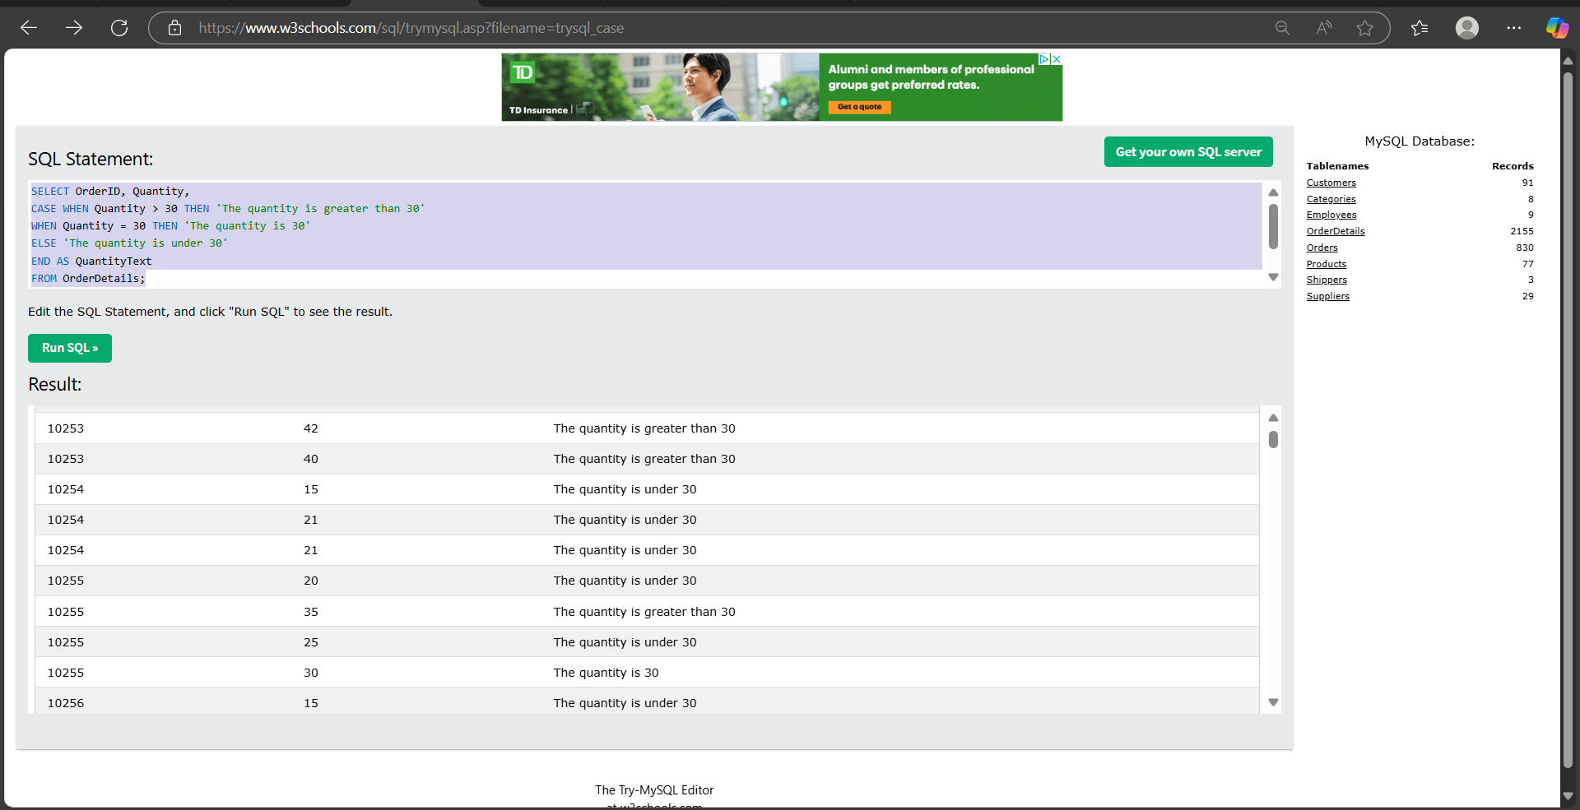

**Create a Report in Looker Studio Using Google Sheets**

#### **Step 1: Prepare Your Google Sheet**

Make sure your sheet is structured in tabular form:

<https://raw.githubusercontent.com/pathwaytipsorg/gcp-data-engineering/refs/heads/master/dproc/data/sale.csv>

Assignment 2

https://drive.google.com/drive/my-drive

Date,Product,Region,SalesAmount  
2025-05-01,Apple,East,100  
2025-05-01,Banana,West,150  
2025-05-02,Orange,North,200  
2025-05-02,Mango,South,180  
2025-05-03,Apple,West,120  
2025-05-03,Banana,North,130  
2025-05-04,Orange,East,220  
2025-05-04,Mango,West,170  
2025-05-05,Apple,North,140  
2025-05-05,Banana,South,160  
2025-05-06,Orange,West,190  
2025-05-06,Mango,East,210  
2025-05-07,Apple,South,115  
2025-05-07,Banana,East,125  
2025-05-08,Orange,North,230  
2025-05-08,Mango,West,185  
2025-05-09,Apple,East,135  
2025-05-09,Banana,South,145  
2025-05-10,Orange,West,240  
2025-05-10,Mango,North,195  
2025-05-11,Apple,West,110  
2025-05-11,Banana,North,155  
2025-05-12,Orange,South,175  
2025-05-12,Mango,East,205  
2025-05-13,Apple,North,165  
2025-05-13,Banana,East,145  
2025-05-14,Orange,West,215  
2025-05-14,Mango,South,185  
2025-05-15,Apple,East,125  
2025-05-15,Banana,North,135  
2025-05-16,Orange,South,225  
2025-05-16,Mango,West,165  
2025-05-17,Apple,South,105  
2025-05-17,Banana,West,155  
2025-05-18,Orange,East,235  
2025-05-18,Mango,North,175  
2025-05-19,Apple,West,140  
2025-05-19,Banana,South,150  
2025-05-20,Orange,North,210  
2025-05-20,Mango,East,190  
2025-05-21,Apple,East,130  
2025-05-21,Banana,North,160  
2025-05-22,Orange,South,200  
2025-05-22,Mango,West,180  
2025-05-23,Apple,North,145  
2025-05-23,Banana,East,135  
2025-05-24,Orange,West,220  
2025-05-24,Mango,South,195  
2025-05-25,Apple,South,120  
2025-05-25,Banana,West,150